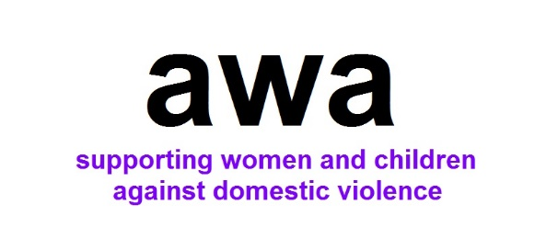

Aylesbury Women’s Aid
Helping Hands Referral Form

How to complete this referral:
By completing this referral form, you are helping us to make contact with the young person as safely and quickly as possible. We would appreciate it if you could include as much information as possible - this helps us to understand more about their particular needs and circumstances.

Helping Hands programmes are delivered within schools and community venues across Aylesbury Vale. Please indicate which type of programme delivery is the preferred option.

How to submit this referral:
Please email this referral to susansmith.awaid@outlook.com

Please ensure that you send the referral form either through a secure email account or with a password protected file.

Eligibility criteria for this service:
Please be sure to check that the client meets the following criteria before making the referral:

- Aged 5 to 11 (school year - one to six), and lives in and attends school in the Aylesbury Vale area
- Experienced domestic violence within their home
- Parent / carer has provided consent for their information to be shared and contacted by AWA

Accompanying documents:
Please attach the following documents to this referral, if completed:

- Consent Form

How to get in touch:
If you have any questions about our service, eligibility criteria, or how to make a referral, please contact enquiries.awaid@outlook.com
Telephone 01296 437777
www.aylesburywomensaid.org.uk

HELPING HANDS - REFERRAL FORM

REFERRER DETAILS
Date of referral
Name of referrer
Agency of referrer
Contact details of referrer
(phone and email address)
Are the parents/carers aware of the referral?
Has consent been given to share information with AWA? | Yes ☐ No ☐
Referral to: | Helping Hands in the Community ☐  Helping Hands in School ☐

FAMILY DETAILS
Name of Parent/s:

Name of child: age: | DOB:
Name of School:

Details of any siblings who will have to accompany the parent (for sessions in the community):
Name: age: | DOB:
Name: age: | DOB:
Name: age: | DOB:
Name: age: | DOB:
Address: | Postcode:
Telephone Number:
Email:

First Language of Parent: | First Language of Child:
Ethnicity of Child:

Any specific problems the child may have that could be relevant to her/his ability to complete the programme:

Does the child have a Child Protection Plan? Yes ☐ No ☐

Is the child considered a CIN? Yes ☐ No ☐

Are there issues with contact arrangements at the present time?

What do you hope will happen as a result of your child taking part in this programme?

For community based sessions - do you need transport for you and your child to attend?

Signed……………………………………………………………………………Date…………………….
(Parent)

Thank you for completing this referral. Please send the completed referral form to
susansmith.awaid@outlook.com or call Susan on 01296 436327

Before you send the referral, please check that your referral meets the criteria set out on the first page of this document, and that any relevant additional documents are attached. Please ensure that you have confirmed consent to share information with AWA.

